TRAINING VENUE SELECTION COMPLIANCE TOOL

VENUE:
STAR CLASSIFICATION: ☐ ☆ ☐ ☆ ☆ ☐ ☆ ☆ ☆ ☐ ☆ ☆ ☆ ☆
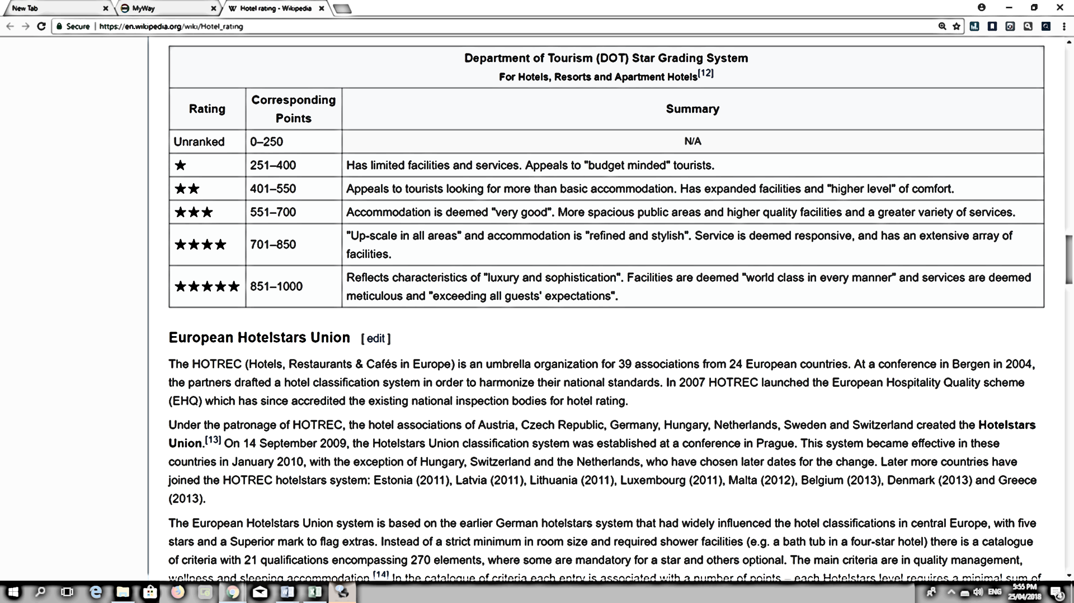

Program Title: |  |  | Date: | Click here to enter a date.

Directions: Please assess the quality of the training venue according to the indicators based on the Standards set in the HRDD Operations Manual. Put a check (/) under the appropriate column. Do further verification.
The training venue shall have: | Compliant | Not Compliant | MOV  (Docs. and Testimonies) | Remarks
- Twin to quadruple sharing rooms (single beds) | ☐ | ☐
- One plenary hall that can accommodate_____ pax, with ___ breakout rooms | ☐ | ☐
- At least two (2) serviceable microphones and complete set of sound system per break out room | ☐ | ☐
- At least two (2) whiteboards in the plenary hall and one (1) white board for each break out room | ☐ | ☐
- One (1) LCD/ DLP for each break out room | ☐ | ☐
- Group workshop table for the breakout rooms (preferably white tables) | ☐ | ☐
- Managed buffet for breakfast, lunch and dinner | ☐ | ☐
- Unlimited coffee/ tea/ chocolate drink and candies setup | ☐ | ☐
- Accessible means of transportation | ☐ | ☐
- Fast and reliable internet connection (at least 10 Mbps) | ☐ | ☐
- Able and willing to ensure provisions for participants and guests with special conditions, example breast feeding moms, PWDs, and other emergency situations. | ☐ | ☐
- Responsive to safety and security requirements of the government | ☐ | ☐
- Been within the area of________________________________ | ☐ | ☐

Justification:
Name and Signature of Evaluator:
Date: | Click here to enter a date.

