**DENTAL HEALTH RECORD**

**Teaching and Non-Teaching Personnel**

Name:___________________________________________ Age:_____Sex:_____ FD:_________

Date of Birth:______________ Birth place:________________Position:_________________

TP or NTP

Contact Number:____________________________

Address:___________________________________________________

**Medical History:**

__ Hypertension __Anemia __Allergy __ Epilepsy ___ Convulsion

__ Heart Ailment __Bleeding Problem __Asthma __ Kidney Disease ___ Fainting Others__________

**DENTITION STATUS**

|  |  |
| --- | --- |
| **INDEX: DMFT** | |
| No. of T/Decayed | X |
| F |
| No. of T/Missing |  |
| No. of T/ Filled |  |
| ***TOTAL*** |  |
|  | |
| Sound |  |
| With Defects |  |
| Caries Free |  |

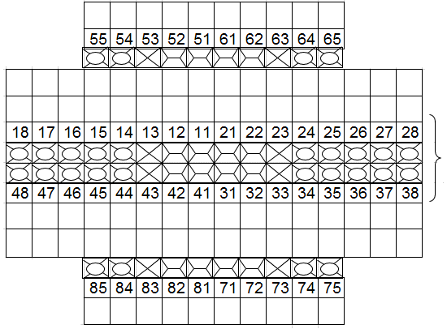

**TREATMENT RECORDS**

|  |  |  |  |  |
| --- | --- | --- | --- | --- |
| *DATE* | *TOOTH NO.* | *NATURE OF OPERATION* | *REMARKS* | *DENTIST* |
|  |  |  |  |  |
|  |  |  |  |  |
|  |  |  |  |  |
|  |  |  |  |  |
|  |  |  |  |  |
|  |  |  |  |  |
|  |  |  |  |  |
|  |  |  |  |  |
|  |  |  |  |  |

|  |  |  |  |  |
| --- | --- | --- | --- | --- |
| **Periodontal Condition:** | | **DENTAL PROSTHESES** | *REMARKS:____________________________* | |
| __ Normal | | Denture Wearer: **YES** **NO** |  | |
| __ Gingivitis | | *Please Specify:______________________* | *REMARKS:____________________________* | |
| __ Periodontal Disease | | Need for Denture: **YES** **NO** |  | |
| Other Abnormal Conditions | | *Please Specify:______________________* | *REMARKS:____________________________* | |
| ________________________ | |  |  | |
| *Please Specify* |  |  | |

**SYMBOLS FOR MOUTH EXAMINATION**

X – Tooth indicated for extraction Gn – Normal

Rf – Root Fragment Gm – Moderate gingivitis

DU – Decubital Ulcer CMR – Complete Mouth Rehab

RC – Recurrent Caries Mal – Malocclusion

TF – Tooth with temporary filling Flu – Fluorosis

F – Tooth indicated for filling (√) – Sound/erupted permanent tooth

Gs – Severe gingivitis Am– Amalgam Filling

M – Missing tooth

**SYMBOLS FOR ACCOMPLISHMENT**

Xt – Extracted Permanent tooth

xt – Extracted temporary tooth

Am– Amalgam Filling

Com – Composite Filing

OP – Oral Prophylaxis

R – Referred

**SYMBOLS FOR ARTIFICIAL RESTORATION**

JC – Jacket Crown

I – Inlay

TF – Temporary Filling

ZOE – Zinc Oxide Eugenol

FB – Fixed Bridge

RPD – Removable Partial Denture

P – Pontic

CD – Complete Denture

PF – Tooth with permanent filling

**TREATMENT RECORD**

|  |  |  |  |  |
| --- | --- | --- | --- | --- |
| **DATE** | **TOOTH NO.** | **NATURE OF**  **OPERATION** | **REMARKS** | **DENTIST** |
|  |  |  |  |  |
|  |  |  |  |  |
|  |  |  |  |  |
|  |  |  |  |  |
|  |  |  |  |  |
|  |  |  |  |  |
|  |  |  |  |  |
|  |  |  |  |  |
|  |  |  |  |  |
|  |  |  |  |  |
|  |  |  |  |  |
|  |  |  |  |  |
|  |  |  |  |  |
|  |  |  |  |  |
|  |  |  |  |  |
|  |  |  |  |  |
|  |  |  |  |  |
|  |  |  |  |  |
|  |  |  |  |  |
|  |  |  |  |  |
|  |  |  |  |  |
|  |  |  |  |  |